**Microprocessor Lab**

Laboratory Activity No. 1

**Familiarization with TinkerCAD**

|  |
| --- |
|  |

Score

*Submitted by:*

**David, Charles Joshua G.**

**Saturday 1:00pm-4:00pm/ BSCpE 412-2**

*Date Submitted*

**16-09-2023**

*Submitted to:*

**Engr. Maria Rizette H. Sayo**

1. Exercise

a. A process in Tinkercad where we can develop electronic circuits that can be quickly updated, modified and tested is called **PROTOTYPING PROCESS.**

b. In Tinkercad, **START/STOP SIMULATION** tests the working of the circuits and the components.

c. The device used to assemble and connect the various components is known as **BREADBOARD**

d. In an electronic circuit with LED, the positive end of the circuit should be connected to

**ANODE** and negative end should be connected to **CATHODE** of the LED.

e. A **RESISTOR** is used to restrict the flow of current to electrical components

2. Label the following:



1. Anode and Cathode in a LED

CATHODE is on the LEFT

ANODE is on the RIGHT

1. Different parts of breadboard

Power Bus

Ground Bus

DIP Support



Terminal Strips

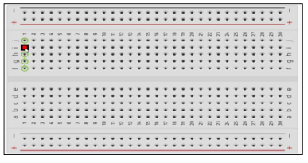



1. List the electronic components used in a circuit assembly

• Resistor • LED • Pushbutton • Potentiometer • Capacitor • Slideswitch • 9V Battery • Coin cell 3V Battery • 1.5V Battery • Breadboard Small • Microbit • Arduino Uno R3 • Vibration Motor • DC Motor • Micro Servo • Hobby Gearmotor • NPN Transistor • LED RGB • Diode • Photoresistor • Soil Moisture Sensor • Ultrasonic Distance Sensor • PIR Sensor • Piezo • Temperature Sensor (TMP36) • Multimeter